CZECH REPUBLIC

The Czech state boast a history spanning over 1000 years and Bohemia, Moravia, and Silesia, the 3 historical lands which form what is now Czech Republic, can each pride themselves on a vast cultural heritage.
A genuine gem among large European cities, Prague, the country’s capital city – an ancient centre situated on the River Vltava – is considered to one of the world’s most beautiful cities.

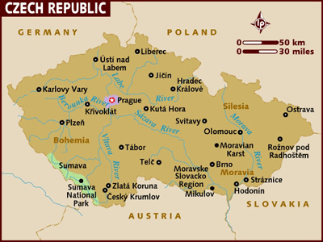

Visa: The visa has to be obtained prior to arrival in the country.

Getting There
Air: International flights mainly arrive into the capital Prague, including CSA (Ceske Aeroline). There is also flights into Brno the country’s second city.
Train: Is the easiest way to get into Czech Republic from Western Europe.
Car: By road visitors can enter the country from 30 different points.

Distances between cities in Netherlands
The following table provides approximate driving distances between major cities in the Czech Kilometres are shown in the lower left of the table, miles in the upper right.
 | Pra | Kar | CeB | Brn | Ost | Kuh | Kro
Prague | • | 23 | 88 | 126 | 234 | 50 | 166
Karlstejn | 37 | • | 87 | 137 | 241 | 89 | 173
Cesk Budejovice | 141 | 162 | • | 134 | 241 | 89 | 173
Brno | 205 | 221 | 216 | • | 109 | 96 | 41
Ostrava | 377 | 393 | 388 | 175 | • | 203 | 68
Kutná Hora | 80 | 85 | 143 | 154 | 326 | • | 134
Kromeriz | 267 | 283 | 278 | 66 | 109 | 216 | •

The Czech Republic has a fairly extensive road network including several motorways linking major cities. The majority of roads are paved and in a reasonable state of repair. Rural areas may not have well maintained roads.
Travellers wishing to drive while in the Czech Republic must carry an International Driving Permit. The minimum driving age is 18. Driving is on the right and you must overtake on the left-hand side. Children should not ride in the front passenger seats and the wearing of seat belts is compulsory.
If you wish to travel on the motorway you will need to display a sticker (vignette) on the windscreen. Vignettes are available for ten day, six month or twelve month periods. Failure to display a vignette can result in a fine.
The speed limit is 130km per hour (81mph) on motorways, 90km per hour (56mph) on major roads outside built up areas and 50km per hour (31mph) in built up areas. You are required by law to carry a warning triangle and first aid kit in the vehicle.
Note that drinking and driving is not tolerated in the Czech Republic. Unlike most countries in Europe where drivers are permitted a small amount of alcohol the legal blood alcohol limit in the Czech Republic is 0mg. Be especially careful if driving in the morning after drinking the night before. Even a trace amount of alcohol is sufficient to incriminate you if involved in an accident - and jail sentences are common for offences. Fines for lesser road offences are steep (up to CZK2000) and can be issued on the spot. If you are involved in an accident resulting in visible damage to your car you will need to obtain a police report and incident number at the scene. Failure to do so can result in permission for your car to leave the Czech Republic being refused.
For emergency road services call the Yellow Angels on Tel: 154.
The following table provides approximate driving distances between Czech cities. Kilometres in the lower left of the table, miles in the upper right.
CURRENCY:
Currency: Czech Krona (Crown) (CZK). CZK1=100 hellers
Notes: CZK20, 50, 100, 200, 500, 1000, 2000, and 5000
Coins: CZK1, 2, 5, 10, 20 and 10, 20, 50 hellers
Credit cards: Visa, MasterCard and American Express are the three most widely accepted credit cards and are accepted in all shops, restaurants and hotels.
Exchange
If you need to exchange currency, banks are your best bet as they charge the lowest commission. Large hotels and exchange offices will change currency but the rates will be much higher. One of the best ways to obtain money is to draw cash from ATMs using an international credit or debit card. ATMs can be found in all towns and cities on most street corners. Check with your bank which ATM systems are compatible with your card. Traveller's cheques are widely accepted and it is advised that you carry traveller's cheques in US Dollars or Pounds Sterling. If people approach you on the street offering to change currency it is wise to refuse.
Service Charges
It is customary to tip in restaurants, bars, cafés, hairdressers and taxis. Except in the more up market international restaurants of Prague rather than adding a percentage to the bill, tips tend to be calculated by rounding up to the nearest figure. Do not give a tip directly to a waiter or leave it on the table but tell the waiter the rounded-up amount you wish to pay when you are handed the bill, and after checking that a little "accidental" rounding-up hasn't already taken place. In taxis, round the total up to the next 20 Koruna.

Telephone

International dialling code: | 420
Area codes: | Prague: 2, Brno: 53/54, Ostrava: 59, Pilsen: 37, Breclav: 51
Public telephone boxes accept both coins and cards, although card operated boxes are most common.
Telephone cards can be purchased from post offices, airports, railway and metro stations, hotels, and "Tabak" kiosks.
The minimum charge for a local call is CZK4. For international directory inquiries Tel: 0135.

Getting Around:
The Czech Republic has an outstanding transport infrastructure with a comprehensive train network, supplementary bus service and well-maintained roads. Public transport within cities is generally good.
Certain transport options may be affected by these public holidays.
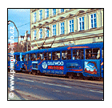
Air: Czech Airlines (CSA) is the national airline of the Czech Republic. Despite the small size of the country, the company operates a number of internal flights connecting Prague with Brno, Karlovy Vary and Ostrava. CSA's City Service Centre can deal with reservations, flight details and general enquiries. Tel: +420 239-007-007.
There are no departure taxes payable when leaving the Czech Republic. All other airport taxes are included in the ticket price.
Train : Czech Railways operates most national services, and also handles bookings for Euro City and Inter City trains. For long journeys. Super City trains offer speed and comfort. Travel on Super City trains is first class only, and services typically include a restaurant carriage, a bar and various other facilities. Staff are friendly and well-informed, and often multi-lingual. It is essential to reserve your seat in advance for a Super City journey.
Express trains lack a little of the luxury of Super Citys, but are cheaper and are still well maintained. These offer first and second class carriages, as well as refreshments. Your journey will take a little longer, as the train will stop at more locations en route.In summer, cyclists can take advantage of the "Sumava lines", which allow bikes to be taken to various locations in the Sumava mountains, such as Ceske Budejovice, Cesky Krumlov, Horni Plana, Nova Pec and Cerny Kriz.
Almost any conurbation in the Czech Republic enjoys reliable public transportation from a selection of trams and "trolley buses". Prague also has a small underground train system, which allows those living in the greater Prague area easy access to the city centre. Tickets for all of these services should be purchased via vending machines at the relevant stop or station. Depending on the length of your stay, you will be able to find a daily or weekly multi-journey pass to suit you. Your ticket should be stamped as you enter the station or on board the tram, using the machines provided.
By Road:
Buses: The state-run company Ceska Statni Automobilova Doprava (CSAD) operates most bus services in the Czech Republic. The service offered is increasingly efficient, and the coach network reaches parts of the country that trains do not. Depending on the operator, you will either buy your ticket in advance (i.e. from the bus station, a ticket machine or a tobacconist) or direct from the driver. Most national buses leave from Florenc in Prague 8, and you can check at the office there for further details on timetable and pricing.
There is a bus info line on Tel: 900-144-444 (service only available in Czech). The smaller Cebus network also connects some of the country's major cities.

CLIMATE
The Czech Republic has four distinct seasons. Spring which falls from March-May, summer from June-August, autumn from September-November and winter from December-February.
The weather varies greatly between the cold winter months and the hot summer months. During winter, temperatures can drop to as low as -10°c and you can expect plenty of snow, frost and ice. By contrast, the summers are pleasant and sunny with temperatures reaching as high as 30°c during June and July.
Given that summers can be fairly wet, a nice time to visit is during May when the weather is warm and dryer or in the early autumn during September.
Climate chart for Czech
TEMP | JAN | FEB | MAR | APR | MAY | JUN | JUL | AUG | SEP | OCT | NOV | DEC
MAX IN C | 4 | 5 | 8 | 11 | 16 | 18 | 21 | 20 | 18 | 13 | 8 | 5
MIN IN C | 1 | 1 | 3 | 6 | 10 | 13 | 15 | 15 | 13 | 9 | 5 | 2
TIME:

Czech is 3 hours and 30 minutes behind India.

ELECTRICITY:
The voltage used is 220 volts.

Food
Be prepared to abandon calorie counting for the duration of your visit to the Czech Republic; food is thick, hearty and filling.
Pork & Fish selections are normally trout or carp, while geese are the preferred choice of poultry.
There's a heavy reliance on sour flavourings, such as sour cream, lemon and vinegar. Goulash and the German sauerkraut, which Czech cuisine has usurped. The distinctive flavour of caraway is an ever- present, it normally is used in no small amount in any cabbage dish, which means it's everywhere.
Desserts are popular, and many follow the hearty, filling format of the main course: fruit dumplings, strudel and crumbles are winter dishes eaten all year round.
A word of caution - it's likely, in tourist places that you'll be presented with a dish of nuts, olives or other finger food when you first sit down. This is not a courtesy and if you touch just one you'll pay for the entire (overpriced) dish when you leave.

TIPS:
Most restaurants will include a service charge, although it is customary to leave a little extra if service has been especially good or friendly. It is customary to give taxi drivers around 10% extra.

LANGUAGE:
Czech (official)

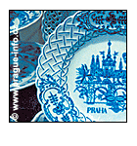
SHOPPING and MUST BUYS:
Glass and crystal
The real Czech specialties are glass and crystal. Both are produced in high quantity and to an excellent standard across the country, so souvenir shopping should be easy. One of the biggest and best factory-shops is the Ruckl Glassworks in Nizbor, a short drive west of Prague (Tel: +420 311-696-111).
Handicrafts
The open-air museum in Roznov pod Radhostem excels in its selection of traditional Czech wooden handicrafts. Carved wooden utensils, ornaments and toys are always favourites with tourists looking for suitably rustic souvenirs.
Wine
The Shining Cross in Znojmo (Tel: +420 515-220-038) is the Czech Republic's largest wine emporium. Situated in the heart of South Moravia, it allows you to sample wines of all price ranges before making your decision.
Antiques
Antique-collectors will be kept busy in Prague. Thanks to the popularity of the Museum of Decorative Arts, there are no end of boutiques and galleries selling high-quality porcelain, furniture, miniatures and jewellery.
Silver
It's hard to beat the town of Kutná Hora for buying silver. Even though it is many years since silver was commercially mined in any great amount here, the town's rich mining history means Kutná Hora is still awash with manufacturers, exhibitors, wholesalers and retailers. It's a short distance to the east of Prague, and easily accessible by rail or car.
Shops are generally open from 08h00/09h00-18h00 Mon-Fri and 08h00-12h00 Sat. Some stores close for lunch between 12h00-14h00. Most shops are closed on Sundays but large department stores will remain open throughout the weekend from 10h00-18h00.

CITIES:
PRAGUE
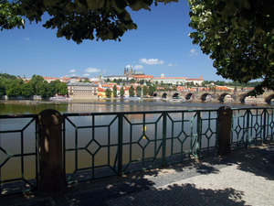
Getting There
Air :. International Airport – Ruzyne Airport.
Train :. Most international trains arrive at Praha Hlavni Nadrazi ( Main Station) and is well connected to rest of Europe . Prague is approx 5hrs away from Munich, Vienna & Berlin.
Bus: The main bus station is called Florenc and one can also drive into Prague. Vienna is 350kms away, while Munich is 450kms away.

City Layout
The river Vltava bisects the city and provides the best line of orientation and the Charles Bridge can be used as the central point.
To the west is the Prague Castle perched on a the hill, also known as Castle District or Hradcany.
Running up the hill between the bridge and the castle is the district known as Mala Strana (Lesser Town) known for the narrow lanes, palaces and red roofed town houses.
To the east bank lies Stare Mesto (Old Town) and further down lies the New Town (Nove Mesto)
Best way to enjoy Prague is to walk around the town.

Getting Around
Prague public transportation network comprises of
Metro (subway)
Trams
Buses
Funicular cog railway makes scenic run up and down Petrin Hill.

ATTRACTIONS
Prague Castle and St Vitus Cathedral
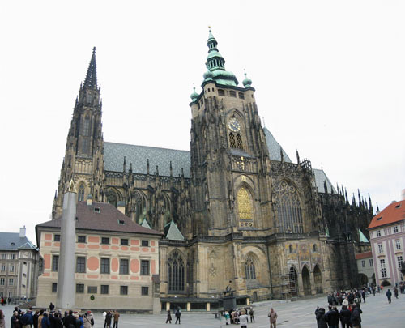
Prague is a magical city, and Prague Castle is a fairytale castle dominating its skyline. With exhibits and features spanning more than 1,100 years of Czech history, it acts as both an ideal starting point for your tour and as an omnipresent landmark in the city's dense, winding layout.
The most inspiring of the many attractions within the castle grounds is undoubtedly St Vitus Cathedral, with its unique, eye-bending exterior and sumptuous interior. Despite the host of paintings and artworks to be seen throughout the castle make sure you take the time to look outwards as well - parts of the grounds offer unparalleled views of the Prague skyline.
Prague National Gallery
Opened to the public in 1804, this is the largest of Prague's countless museums and galleries.
The institution actually comprises several galleries housed in separate buildings including the huge modern art centre. The entire collection encompasses Czech and international artists of note, from all schools of art.
The Gallery of Modern & Contemporary Art's huge minimalist home is popular while the National Gallery's collection of Old Masters is housed in the Sternbersky Palace.
See our Prague guide for more details of the city.
Charles Bridge – The oldest Prague bridge built in the place of the Judita's Bridge that had been badly damaged by a flood in 1342. The Stone or Prague Bridge since 1870 called Charles Bridge, was founded by Charles IV in the year 1357. By the latest researches the construction was started by Master Otto and finished by Peter Parler in 1402. Both ends of the bridge are fortified by towers (the Lesser Town Bridge Towers, the Old Town Bridge Tower). From 1683 to 1928 thirty sculptures and sculptural groups of the saints were gradually set on the bridge piers .The Bridge is 515 meters long and 10 meters wide.
Address: Praha 1 - Stare Mesto; Praha 1 - Mala Strana
Church of Our Lady of Victory - the Prague Bambino (Panna Marie Vitezna - Prazske Jezulatko)An early baroque building from the year 1611, 1634 - 1669 rebuilt by the Carmelite Order. The church is world-famous thanks to the Prague Bambino - Infant Jesus wax figure (of the Spanish origin), which was presented to the church by Polyxena of Opening hours: January – December 8.30 Monday – Saturday; 8.30 Sunday. Address: Lobkowicz (1628).Karmelitska 9
Praha 1 - Malá Strana
118 00
Phone: 257 533 646
Fax: 257 530 370
E-mail: mail@pragjesu.info
Web: http://www.pragjesu.info
St Nicholas Church – One of the most valuable buildings of the "Prague Baroque" period with a dominant dome and the belfry (architects K. Dienzenhofer, K. I. Dienzenhofer, A. Lurago, 1704 - 1756). Also the inside decoration of the church is a specimen of the high baroque style (J. L. Kracker, K. Skreta). W. A. Mozart played the organ here during his stay in Prague.
Most significant historical monument also called Prague Baroque. Permanent exhibition: Prague Bells
Church of St Nicholas (Sv. Mikulas - kostel - Mala Strana)
Address: Malostranske nam.
Praha 1 - Mala Strana
118 00
Phone: 257 534 215
Fax: 257 534 215
E-mail: info@psalterium.cz
Web: http://www.psalterium.cz Opening Hours daily
Old Town Bridge Tower (Staromestska mostecka vez)
The entrance gate to the Charles Bridge from the Old Town river bank, the most beautiful gate of the Gothic Europe was a masterpiece of the Court Buildingworks, it was finished before 1380. It is richly adorned with sculptures - coats of arms of the countries belonging to the Czech Crown under the reign of Charles IV, statues of St. Vitus, Charles IV, Wenceslas IV, St. Vojtech (Adalbert) and Sigmund.
Permanent exhibition:
"Charles Bridge - ray through centuries" - the picture about the astrological and astronomic relations of the origins of Charles bridge.
Guided tours are organised by the Prague Information Service.
Address: Karluv most
Praha 1 - Stare Mesto 110 00
Phone: 224 220 569
Web: http://www.pis.cz

Old-New Synagogue (Staronova synagoga - Zidovska obec v Praze)
The oldest preserved synagogue in the Central Europe. It was built in the early gothic style in the late 13th century and richly adorned by stonework. Also the inside furnishings (gothic wrought-iron grill, wrought chandeliers) are of ancient origin. Up till now it has served as a house of prayer and the main synagogue of the Prague Jewish community.
Address: Cervena 2
Praha 1 - Stare Mesto/Josefov110 00
Web: http://www.synagogue.cz
Opening hours daily except on Sat and Jewish feasts

Our Lady Before Tyn (Panna Marie pred Tynem)
The most impressive gothic sacral building in Prague the construction of which lasted from the mid-14th to the early 16th century. In the late 17th century the church interior was rebuilt in the baroque style. Its interesting decorations include valuable altar paintings by Karel Skreta and a tombstone of the astronomer Tycho de Brahe. At present renovation of a part of the interior is in progress.
Address: Staromestske nam. 604
Praha 1 - Stare Mesto
110 00
Phone: 222 318 186
E-mail: dkc@cmail.cz
Web: http://tynska.farnost.cz
Old Town Hall (Staromestska radnice)
Established 1338 as the seat of the Old Town authorities. The oldest gothic part of the complex which includes a tower and an oriel chapel is richly decorated with coats of arms. It was built in the latter half of the 14th century. In the top part of the astronomical clock (early 15th century) the 12 apostles appear every hour between 9 a.m. and 9 p.m the bottom part was supplemented with a round calendarium including the signs of the zodiac painted by Josef Manes (1865). The eastern pseudo-gothic wing of the Town Hall was destroyed on May 8, 1945, and has not been rebuilt yet. Opening hours January – December on Monday & Tuesday - Sunday
Address: Staromestske nam. 1/3
Praha 1 - Stare Mesto 110 00
Phone: 724 508 584
Web: http://www.pis.cz
National Museum (NÁRODNÍ MUZEUM - hlavni budova)
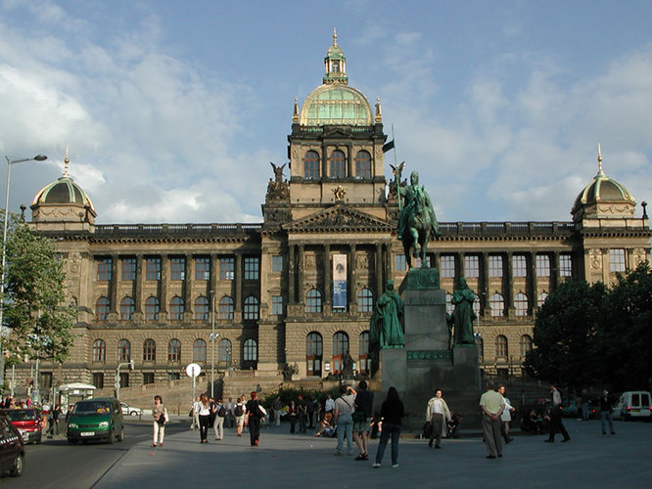
The largest and oldest Czech museum founded in 1818 is housed in a monumental neo-renaissance building from the years 1885 - 1890 that dominates the Wenceslas Square.
Permanent exhibitions:
Primeval history of Bohemia, Moravia and Slovakia * Mineralogical and petrological collections * Zoological collections * Palaeontological collection * Anthropological collection
Address:Vaclavske namesti 68
Praha 1 - Nove Mesto
115 79
Phone: 224 497 111
Fax: 222 246 047
E-mail: nm@nm.cz
Web: http://www.nm.cz
closed on first Tuesdays of the month &every first Monday in a month no charge for admission

St Nicholas's Church
The most significant of Prague's baroque buildings, St Nicholas's church is situated in the Mala Strana between the castle area and the Vltava River. The castle's massive dome dominates the surrounding area, making St Nicholas's easily visible from all over the city.
Inside, the church's proudest possession is the massive fresco, stretching across the nave and depicting the life of St Nicholas. The interior amply demonstrates all the colourful trappings that defined the baroque period, with bold marbled features in rich abundance. Interestingly three generations of the same family of architects worked on the cathedral in the hundred years it took to build. The dome and over-the-top interior were designed by Kilian Ignaz Dietzenhofer, following his father's work on the front façade. Kilian himself designed the sumptuous white façade of Prague's other St Nicholas's Church near the Old Town Square.
Mozart famously gave piano recitals in the church and his works are still regularly played here for audiences eager to hear his music in these magnificent surroundings. Malostranske Namesti, Mala Strana. Open: daily 09h00-16h00 (Nov-Mar); 09h00-17h00 (Apr-Oct) Tel: +420 257-534-215.
Mala Strana
The Mala Strana or "Little Quarter" is quintessential baroque Prague. Within its confines lie some of the capital's true architectural gems. As well as St Nicholas's Church (see above) the Valdstejnsky Palace, with its grandiose gardens, and the Panna Maria church are well worth exploring.
The Mala Strana is also home to the funicular railway, which travels to and from Petrin Hill. With the towering Prague Castle in the background and the city stretched out to the east, the views from here are always spectacular.
Wenceslas Square
Wenceslas Square lies at the heart of Prague and is considered the centre of the city, straddling the gap between old and modern Prague.
The "square" is more like a broad avenue, which stretches from north-west to south-east and culminates in the towering statue of St Wenceslas standing proudly before the almost equally impressive National Museum.
In the late 20th century the square bore witness to many anti-Communist demonstrations including the "Velvet Revolution" of 1989 which heralded the Czech Republic's (as part of Czechoslovakia) independence from the USSR.

Jewish Quarter
The Jewish Quarter witnessed the most sinister and barbaric period in Prague's history. The thriving Jewish community was almost completely destroyed by a series of pogroms and deportations following the Nazi invasion of 1938. However, the remnants of Jewish life still live on through the synagogues and the famous Jewish cemetery, which typifies the overcrowded nature of the ghetto throughout its 900-year history.
Jewish Museum incorporating four synagogues, Old Jewish Cemetery and Ceremonial Hall open: Sun-Fri 09h00-16h30 (Nov-Mar); 09h00-18h00 (Apr-Oct). Tel: +420 222-317-191

Sternbersky Palace
The Sternbersky Palace is just one part of the most impressive of Prague's art collections, which come under the umbrella of the National Gallery.
The palace houses an outstanding collection of European paintings from the 14th to the 18th centuries, including Durer's masterpiece The Feast of the Rosary.
Hradcanske namesti 15. Open: Tue-Sun 10h00-18h00. Tel: +420 233-090-570.

Konepruske Jeskyne
The whole of the Cesky Kras region around Prague contains fascinating cave and rock formations but the Konepruske Jeskyne is the only cave network open to public access.
The caves are situated in the small village of Beroun, 20km south-west of Prague. Only discovered in the 1950s the upper level was once used to house a secret forger's mint. Not regularly visited by large groups, the Konepruske Jeskyne provide an ideal opportunity to escape the tourist masses and still see something worthwhile. Open: daily 08h00-16h00 (Apr-Oct) (with slight seasonal variations). children; free for under 6s. Tel: +420 311-622-405.

Excursions
Karlovy Vary:
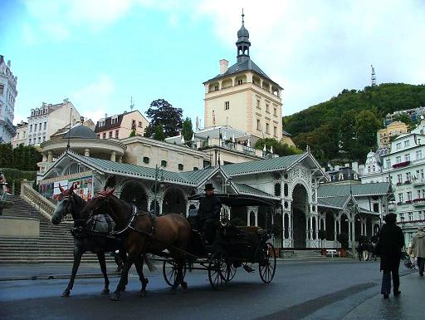 T
The second biggest tourist draw in the Czech Republic, Karlovy Vary is a fabulous spa town. Distance from Prague: 130 km
The period buildings dating from the 18th and 19th centuries are remarkably grand and it is easy to imagine the wealthy upper classes of their day flocking to the town to take the restorative waters. Hot springs eternal
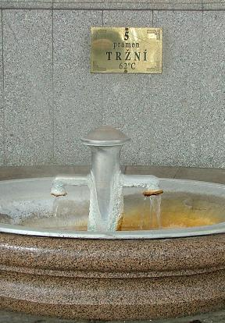
The natural mineral water springs of Karlovy Vary were considered to have healing properties as early as the first written mention of the town, in 1370. ‘The Cure’ originally consisted of long baths, and not until the 16th century was it fashionable to actually imbibe the waters. While 70 cups a day are no longer recommended, prescribed spa patients and casual visitors alike are enthusiastic drinkers of the natural mineral water that gushes in a dozen places from the ground beneath Karlovy Vary.
The town is still a draw for today's rich and famous and is a delightful spot for a bit of rest from the big city of Prague - only 150km away. Golf courses and fabulous countryside surround the town, allowing visitors to be as active or idle as they wish.
Karlstejn Castle
The 14th-century castle at Karlstejn is one of the Czech Republic's most visited tourist sites. No wonder, given its imposing exterior and highly decorative interior, built in three layers that symbolically represent the secular world, purgatory and heaven. The Emperor Charles IV had the castle built 40km south-west of Prague as a repository for the crown jewels and a place to store the pile of holy relics he earnestly collected.
With walls encrusted with semi-precious stones and a collection of 129 Gothic paintings by Master Theoderik, the Chapel of the Holy Rood is the central attraction of the complex. The niche in the altar once housed the Czech Coronation Jewels.
The castle's surroundings are equally delightful - the towered structure is located on a rocky outcrop among several hills. 45 min walk from centre (Old Town Hall) Visit: Prague Castle Complex:
April - October 5 a.m. - 12 p.m. (daily)
November - March 5 a.m. - 11 p.m. (daily)
Parts with charge:
(St.Vitus Cathedral, Old Royal Palace, St.George Basilica, Golden Lane, Powder Tower-Mihulka)
April - October 9 a.m. - 5 p.m. (daily)
November - March 9 a.m. - 4 p.m. (daily)
Parts free of charge:
(Gardens of Prague Castle)
April - October 10 a.m. - 6 p.m. (daily)
Information Centre of Prague Castle
Visit: 9 a.m. - 5 p.m. (daily)
9 a.m. - 4 p.m. - during the winter season (daily too)
Address: Hrad Karlstejn, 267 18 Karlstejn, Czech Republic
Website: www.hradkarlstejn.cz
KUTNA HORA

Just 70km from Prague, Kutna Hora at one time was second only to the capital in terms of wealth. The town's prosperity was due to the discovery of silver in the 13th century and the royal mint was established here. The many fine buildings of the town bear testament to this period of prosperity and it is now a UNESCO world heritage site.
St Barbara Cathedral
The crowning glory is the cathedral of St Barbara, one of the grandest structures in Europe. St. Barbara’s is the most spectacular gothic cathedral in the Czech Republic, a land noted for its Gothic cathedrals. It’s difficult to appreciate the splendour of the cathedral from close up, and impossible to capture it in a photograph. The intricacy of the flying buttresses, the unique tent-like sailing spires, and the marvelous cliff-top setting combine to make a visit to the cathedral an awe-inspiring experience. 10 min walk from the centre (Palackeho Square)
Visit: November-March 9 a.m. - 11.30 a.m.; 2 p.m. - 3.30 p.m. (except Mondays)
April and October 9 a.m. - 11.30 a.m.; 1 p.m. - 4 p.m. (except Mondays)
May-September 9 a.m. - 5.30 p.m. (except Mondays)
Opening Hours: St Barbara’s is open year round; May thru September from 9am to 6pm, and the rest of the year from 9:00 am is to 4.30pm. Be careful if visiting on a Monday though, because the cathedral will only open from 10am to 4.30pm and on winter Mondays (November thru March) it will be closed.
Address: Chram sv. Barbory
Jakubska 1
28401 Kutna Hora
Tel. 327 512115
The ossuary of Sedlec is also a unique attraction not to be missed. So many people desired to be buried on the holy ground here that a local woodcarver was commissioned to do something with the bones that had built up over the centuries. He transformed the chapel, building chandeliers, chalices and wonderful decorations from human skeletons, even signing his name, Frantisek Rint, in bones when he had finished. The bone church is open 7 days a week year round, except on the 24th and 25th of December.

KONOPISTE
Another of the grand castles that are littered around this part of the world, Konopiste was once a fairytale type castle that wouldn't have looked out of place in a Disney park.
However, the main defensive walls were lowered in the 17th century and the central keep turned into a grand Renaissance chateau. Set in a wooded valley, the building's towers are still an imposing sight and, inside, the chateau is just as impressive as it must have been at the height of its glory.
The richly decorated rooms are full of artworks, chandeliers and tapestries while the armoury is a fearsome reminder of the days when the chateau was built for defense. Archduke Franz Ferdinand, whose assassination sparked World War One, often stayed in the castle. Konopiste lies 44km south-east of Prague.

KRIVOKLAT
There has been a castle at Krivoklat since the early 1100s but the one that now stands in the wooded valley is predominantly a 16th-century construction.
The castle is nevertheless extremely impressive with its distinctive white tower rising majestically from the surrounding woodland. The forest was once a favourite hunting ground for the Czech nobility who used to use the castle as a base for expeditions in the area.
Inside, highlights include the library, which contains well over 20,000 precious manuscripts and writings, and the massive Gothic style hall. Visitors can also see the grim torture chambers and gaol. Krivoklat is situated 40km west of Prague.
CESKY KRUMLOV

Český Krumlov is a unique architectural jewel, whose importance is underlined by the fact that it was included in the UNESCO List of the World Cultural Heritage in 1992. Above the meanders of the river Vltava a unique complex of municipal housing developed, mainly in the 16th century, along with an extensive castle and chateau complex, the second largest in the country after...

BRNO
Distance from Prague: 210 km. The second largest town in the country and Moravia’s traditional capital, Brno was also the historic seat of the Přemyslid dynasty. King Wenceslas I awarded Brno municipal status as early as 1243. The city’s skyline is dominated by the Špilberk castle, where an early-Gothic palace with two chapels is still standing. Later on, the castle was converted into a baroque fortress, and in the 19th... Brno also offers destinations outside the city center – the city ZOO, motor sports enthusiasts flock to the Automotodrom Brno with the new Masaryk Circuit – a venue of the World Moto Grand Prix.
UNESCO monument of modern architecture.
The Villa Tugendhat in Brno –
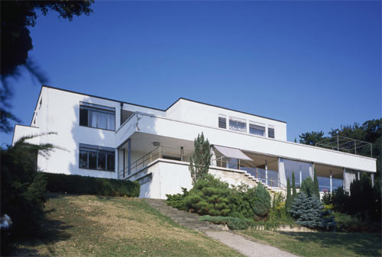

It is the very first monument of modern architecture in the Czech Republic and only the fourth worldwide which has received the prestigious UNESCO designation. The building is named after Fritz Tugendhat, owner of a Brno textile factory, who had this jewel of interwar functionalist architecture built for his family.
The glass-fronted villa set on a grassy slope was designed by famous German architect Ludwig Mies van der Rohe in 1928. Mies was able to utilize exquisite materials and modern technologies of the ealy 20th century. The Villa Tugendhat is described by architecture scholars as a breakthrough work of modern architecture in the international context.
Location: 20 min walk from the centre (square: Namesti Svobody) Address: Cernopolni 45, 613 00 Brno, Czech Republic www: www.tugendhat-villa.cz

Spilberk Castle –
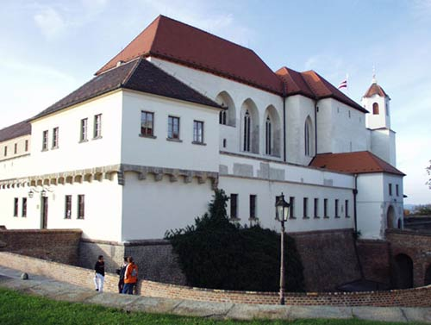
Originally a royal castle, founded in the 13th century, rebuilt in the 17th century into a sizeable Baroque fort. Till 1945 there was a prison and barracks. 'Kasematy' – Baroque fort architecture and prisons in the Josephine era. The prison of the nations – the famous prison of the Habsburg Monarchy.
Location: 10 min walk from the centre (square: Namesti Svobody)
Address: Spilberk 1, 613 00 Brno, Czech Republic
Website: www.spilberk.cz

Cathedral of St. Peter and Paul

The Cathedral of St. Peter and Paul is located on the top of the hill, known as Petrov, on the presumed site of the former Brno castle. After the castle’s demise the free-standing Romanesque basilica was rebuilt as a Gothic cathedral in the 13th century and converted to the Baroque style in the 18th century. Its current neo-Gothic form dates from the turn of this century. Since 1777 the cathedral has been the seat of the Brno bishopric.
Location: 10 min walk from the centre (square: Namesti Svobody)
Address: Petrov, 613 00 Brno, Czech Republic

The oldest secular building in Brno.
The city administration was situated in this, the oldest secular building in Brno until 1935. The historical origins of the building go back to around 1240. Location: 5 min walk from the centre (square: Namesti Svobody. Address: Radnicni, 613 00 Brno, Czech Republic

St James Church
The city church of St. James stands as an example of the standard of building from the end of the 14th until the 16th century. The eastern section of the choir was decorated with Parler's fan vaulting prior to the outbreak of the Hussite Rebellion. Work on the building continued from the mid 15th century, and from 1502. The tower was completed in 1592.
Location: 5 min walk from the centre (square: Namesti Svobody)
Address: Rasinova, 613 00 Brno, Czech Republic

The Basilica of the Assumption of Our Lady
It is a true jewel amongst Gothic architecture in Moravia. The widow Queen, Eliska Rejcka, established the Cistercian convent in 1323 next to the old parish church of Our Lady.
In 1868 Johann Gregor Mendel was elected Augustinian abbot, and it was in this monastery that he discovered and formulated his theory of genetics.
In 1987 the Old Brno church was elevated in status by Pope John Paul II, and from that time it has carried the title 'Basilica minor'.
Location: 10 min walk from the centre (square: Namesti Svobody)
Address: square Mendlovo namesti, 613 00 Brno, Czech Republic

PLZEN
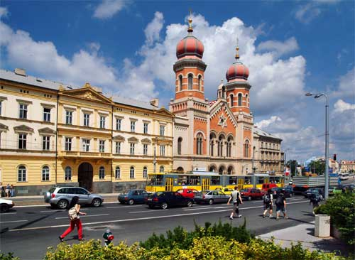
The West-Bohemian metropolis with 170,000 inhabitants is the fourth largest city in the Czech Republic. Its historical predecessor was a former watch castle dated from the 10th century on the place of the recent Starý Plzenec. The pre-Romanesque Rotunda of St. Peter dates back to that period. In the late 13th century, a new royal town ground plan was built on the confluence of four rivers . The Plzen is world-famous for the local brand of beer - Pilsner Urquell.
The town was built on a chessboard plan in 13th century and is an example of High-Gothic urbanism.
The medieval Cathedral of St.Bartholomew includes the highest church tower in Bohemia (103 m). The Plzen Great Synagogue from 19th century is the 3rd largest synagogue in the world and the West Bohemian Museum has an oldest known collection of Central European armoury. Also the wonderful Brewery Musem is one of the oldest of its kind in the world.
Monumental Town Hall, historical underground, houses of citizens, unique beer Pilsner Urquell made from Plzen interesting place where it is possible to spend a few days.

Indian Restaurant

Haveli
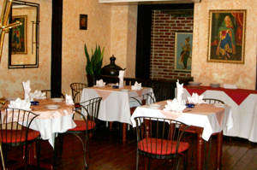
Dejvicka 6, Prague 6
(near the Hradcanska metro station)
Open daily from 11.00 - 23.00
Tel.: 233 344 800 - 3
Fax.: 233 341 349
Website: http://www.haveli.cz/
E-mail. info@haveli.cz

Himalaya
Mikovcova 7, Prague 2
Tel: +420224 231 581, +420603 146464
Opening hours: Mon – Fri 11am – 11 pm
Sat – Sun – 12 am – 11 pm
Website: http://www.himalayagroup.cz/

Rasoi
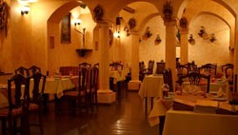
Dlouha 13, 110 00 Praha 1
Tel: +420 222 328 400
fax: +420 222 323 349
E-mail: restaurant@rasoi.cz
www.rasoi.czOpen daily: 4.00 p.m. - 11.00 p.m.

Bombay Cocktail Bar
Dlouha 13, 110 00 Praha 1
Tel: +420 222 324 040
fax: +420 222 323 349
E-mail: restaurant@rasoi.cz
www.bombaybar.cz
Open daily: Sun - We 5.00 p.m. - 4.00 a.m.,
Thurs 5.00 p.m. - 5.00 a.m., Fr - Sa 5.00 p.m. - 6.00 a.m.
Taj Mahal
Skretova 10, Prague 2(Behind the National Museum)
Metro - station MUZEUM, tram no. 11
Telephone for reservations: 224 225 566
Opening Hours: Monday - Friday: 12:00 - 23:00
Saturday - Sunday: 13:00 - 23:00
Website: http://www.tajmahal.cz/
E-mail: info@tajmahal.cz

